

# Type of Manuscripts (Times new roman 12): Original , Review , Case Report…..

**Title (Arial 20): Use of Polymers in the Dental Industry**

# Authors names (Arial 12): Ali Kadhim Wadday a,*, Sukaina Tuama Ghafel a

**Affiliation (Times new roman 6):** a Scientific Research Center, Al-Ayen University, Thi-Qar, 64001, Iraq

**ABSTRACT (Times new roman 9)**

The medical field has evolved over the years, using natural and synthetic materials, so it was necessary to develop polymers, which are present in most materials used in the medical and dental industries, with the aim of making missing parts fix or move to compensate for teeth , and these materials included in dental allowances must be harmless and suitable for the human body, so this study focuses on these types of uses and applications, focusing on different polymers and their applications in the dental industry. A new polymer paste made from PEEK polyetheretherketone was identified as an option for the dental industry because dental polymers generally do not need to be replaced.

**Keywords (Times new roman 9):** Polymers, Dental Industry

## Introduction (Times new roman 10)

Dental polymers are resins for dental fillings, braces, dentures, and other water-insoluble resins [1]. Usually they’re some type of plastic that’s mixed with other materials to create a hard, tooth-like ap- pearance that lasts a long time. Most dentists use some form of polymer in at least some of their cos- metic dental work. There are different types and brands of dental polymers, but it gets its name from mixing several different materials together to make a filling. The physical properties of polymers are af- fected by temperature and environmental changes as well as the composition, structure and molecular weight of the polymer. In general, the higher the temperature, the softer and more brittle the polymer becomes [2–5]. Polymers can be formed into any de- sired shape using methods depending on whether the polymer material is a “thermoset” or “thermoplastic” type. Each of them has different properties [6,7,8].

## Materials and methods (Times new roman 9)

## Acrylate polymers are a group of polymers made from acrylate monomers. These plastics are char- acterized by transparency, breaking strength and elasticity. They are also commonly known as acrylics or polyacrylates. It allows for repositioning of the base when the supporting tissue changes, is aes- thetically superior to metal bases, and is easier to repair. But it has less detrimental effect on dimen- sional stability than metal-based warping and less strength than metal—large spans, porous hygiene and low thermal conductivity [12]. Poly(methyl methacrylate) is the scientific name for a synthetic polymer commonly known as acrylic, acrylic glass,

Received xx xxx 2024; accepted xx xxx 2024. Available online xx xxx 2024

* Corresponding author.

E-mail address: xxxxxxxx

2

and plexiglass. If not modified, it is brittle, transpar- ent and light. It is translucent and can be modified to provide a variety of cast color options, textures and shapes [1].

Polyetheretherketone (PEEK) is a colorless or- ganic thermoplastic polymer belonging to the pol- yaryletherketone (PAEK) family used in engineering and medicine. Due to its aesthetic properties, it is con- sidered an alternative to traditional dental materials and is a scientifically recognized material. Restora- tively, it can be used for removable partial dentures, fixed partial dentures, implants, abutments, implant crowns, and restoration of maxillofacial defects [6].

## Results and discussion (Times new roman 9)

Manufacturing Steps Removable Dentures Manu- facturing partial dentures with outstanding aesthetic and functional results requires careful planning. To achieve good results, several steps need to be done [16,17]. Step 1: Initial impression; Step 2: Make cus- tom tray and bite ring; Step 3: Fasten and bend; Step 4: Illustrate model; Step 5: Inlay; Step 6: Waxing; Step 7 : bottling; the eighth step: mixing acrylic; the ninth step: acrylic; the tenth step: finishing; the eleventh step: polishing as shown in Fig. 1.

* 1. *Steps of manufacturing removable denture by using PMMA polymers*

Procedures for manufacturing removable dentures using PMMA polymer Dissolves the PMMA particles and disperses the polymer chains in the liquid phase [2]. Simultaneously, the larger PMMA particles start to expand and increase in viscosity. Typically, the fibrous stage is characterized by the formation of viscous threads upon contact or stretching and fur- ther development to the doughy stage. However, the mixture still contained many undissolved polymer chains. This stage is characterized by loss of threads and stickiness. In addition, the mixture at the dough stage is considered suitable for filling into tooth jars, and the dough development time (from mixing to

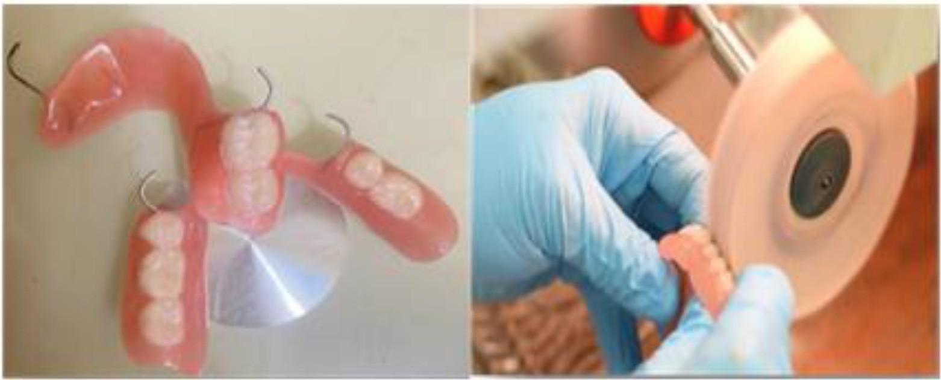

**Fig. 1. (Arial 8)** Finishing manufacturing removable denture by using Acrylic polymers.

## 

|  |  |  |  |
| --- | --- | --- | --- |
| **Table 1.** Textural properties of CRW, HTC200, PY700, and MW800. | | | |
| Sample | Area | Surface | Dimeter |
| X | X | X | X |
| X | X | X | X |
| X | X | X | X |
| X | X | X | X |

## Conclusion (Times new roman 9)

Each polymer has many advantages and disad- vantages. Materials used in the dental industry are constantly evolving in order to provide adequate comfort for patients. The use of PMMA started to reduce its fracture properties, despite increasing it, today dental technicians completely rely on acrylic for removable dentures due to its high esthetic prop- erties and su cient comfort for the patient. However, some patients resent this material.

3

and thermal properties; PEEK material is the best polymer used in the dental industry. PEEK has a high strength-to-weight ratio and comes in a natural, non-contrasting colour, making it look more natural in the patient’s mouth. This lightweight material is digitally designed and manufactured for greater ac- curacy and fit. PEEK is preferred over metal in the patient’s mouth because it eliminates any metallic taste or temperature changes in food.

## Recommendations (Times new roman 9)

We recommend the use of the PEEK polymer, and studying it, we support work on it in dental clinics and the use of CAD-CAM technology.

## Acknowledgment (Times new roman 9)

We thank Al-Ayen University College of Health & Medical Technology/ Department of Prosthodontics, for helping to complete this work.

## Conflict of interest (Times new roman 9)

Declare conflicts of interest or state “The authors declare no conflict of interest.” Authors must identify and declare any personal circumstances or interest that may be perceived as inappropriately influenc- ing the representation or interpretation of reported research results.

## References

* 1. Rokaya D, Srimaneepong V, Sapkota J, Qin J, Siraleart- mukul K, Siriwongrungson V. Polymeric materials and films in dentistry: an overview. *J Adv Res*. 2018;14:25–34. doi: [10.1016/j.jare.2018.05.001](https://doi.org/10.1016/j.jare.2018.05.001)
  2. Calhoun A. Polypropylene. In: Wagner JR, ed. *Multi- layer Flexible Packaging*. 2nd ed. Elsevier; 2016:35–45. doi: [10.1016/B978-0-323-37100-1.00003-X](https://doi.org/10.1016/B978-0-323-37100-1.00003-X)
  3. Pavon C, Aldas M, Rayón E, Arrieta MP, López-Martínez

J. Deposition of gum rosin microspheres on polypropylene microfibres used in face masks to enhance their hydropho- bic behaviour. *Environ Technol Innov*. 2021;24:101812. doi: [10.1016/j.eti.2021.101812](https://doi.org/10.1016/j.eti.2021.101812)

* 1. Meraldo A. Introduction to bio-based polymers. In: Wagner JR, *Multilayer Flexible Packaging*. 2nd ed. Elsevier; 2016:47–

52. doi: [10.1016/B978-0-323-37100-1.00004-1](https://doi.org/10.1016/B978-0-323-37100-1.00004-1)

* 1. Park SJ, Seo MK. *Composite Characterization*. Vol 18. Elsevier; 2011. doi: [10.1016/B978-0-12-375049-5.00008-6](https://doi.org/10.1016/B978-0-12-375049-5.00008-6).